**Dengue Detection using ML**

**In Dengue detection using Machine learning algorithms, we have used Random forest, Decision tree and MLP classifier. By using python 3.7.0 and jupyter editor, code is executed.**

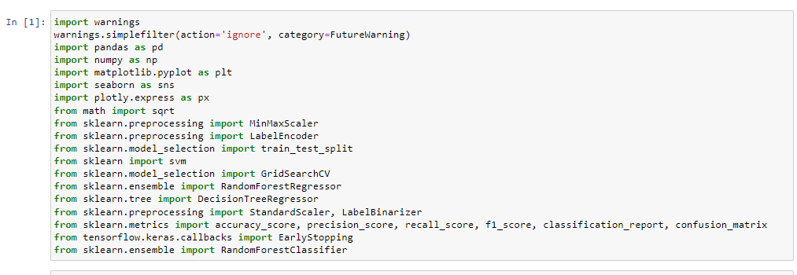

Fig: Loading Libraries

First step is loading the important and required packages.

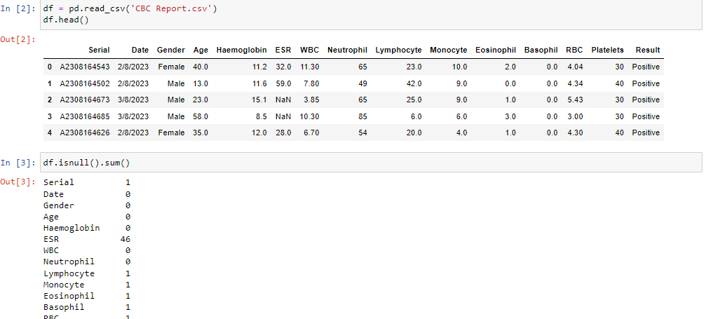

Fig: Read the dataset

‘CBC Report.csv’ is dataset is loaded and displaying the first five records of dataset. After that checking null values.

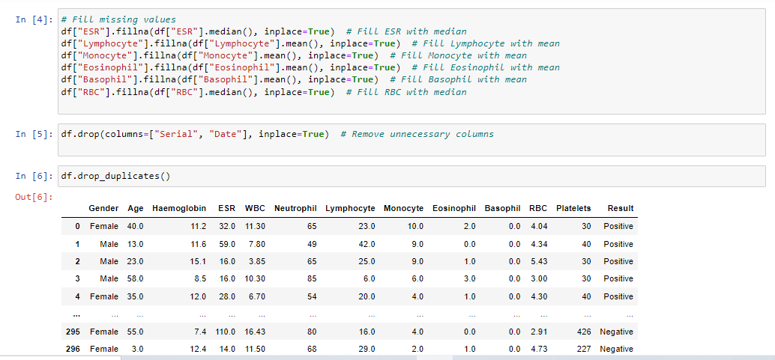

Fig: Data Preprocessing

Data processing means cleaning the data for training the model. Here dropping unnecessary columns , dropping duplicate values and filling missing values process is done.

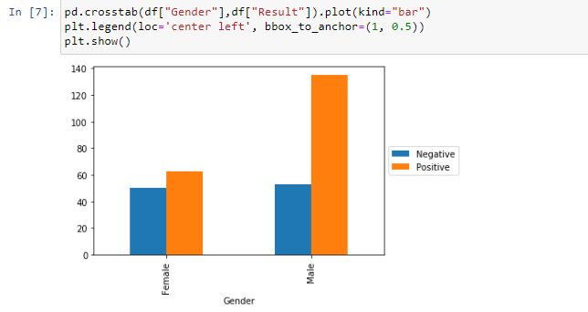

Fig: Data Visualization

Here we are checking the distribution of Dengue test with gender.

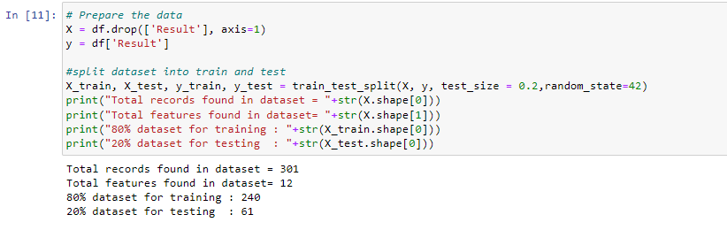

Fig: Dataset Splitting

Dataset is split into training and testing the data.

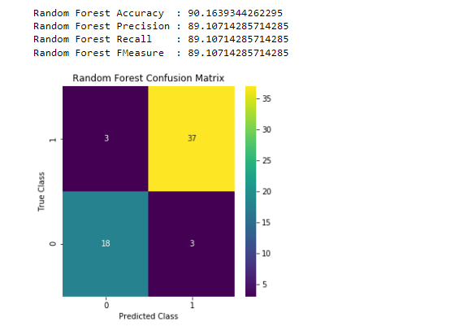

Fig: Random Forest Performance

Random forest is trained with 80% data and given the accuracy, precision ,recall and fscore. Confusion matrix is displaying true values and predicted values.

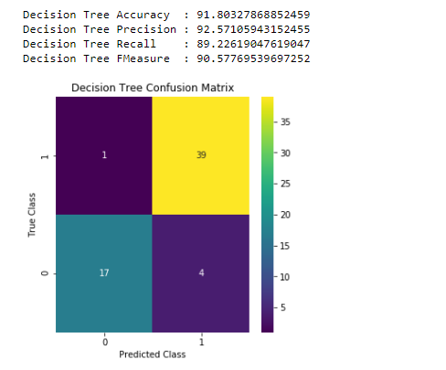

Fig: Decision Tree Performance

DT is giving highest accuracy among all three algorithms.

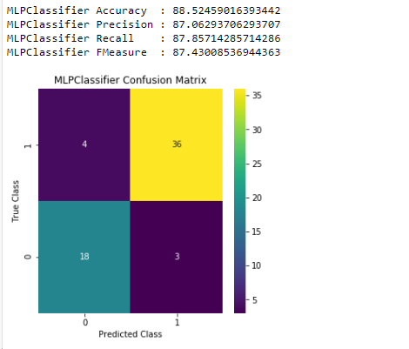

Fig: MLP Performance

MLP is giving lowest accuracy among all three algorithms so considered as existing method.

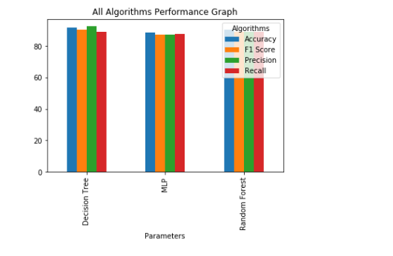

Fig: All algorithms performance in bar graph

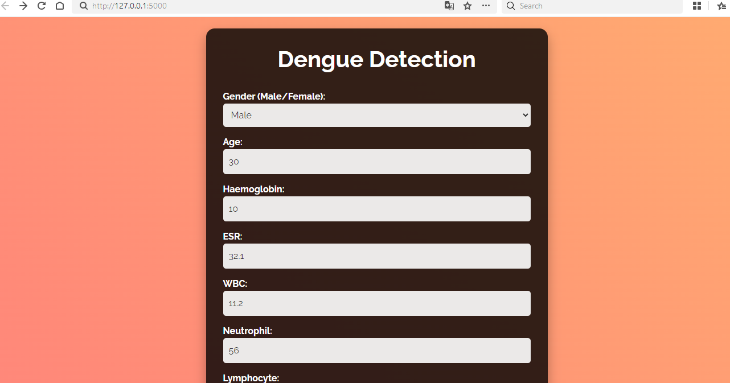

Fig: Dengue Detection

Entering the values for dengue test detection such as WBC, RBC, Haemoglobin,others.

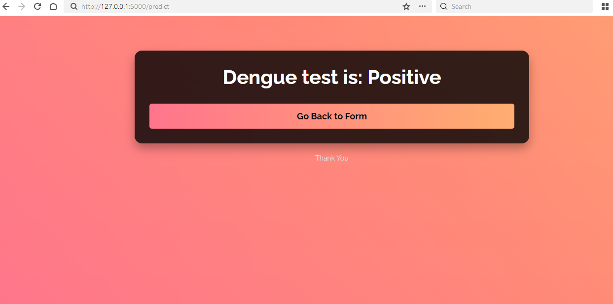

Fig; Dengue test prediction

After entering all values dengue test is predicted as positive.